Summary (what project and main findings)—100-200 words lasya and Claudia

Brand ambassadors are valuable assets for enhancing a brand’s credibility, relatability, and visibility. When chosen strategically, ambassadors can strengthen brand image and expand reach to underserved audiences, often translating to increased sales and awareness. This is backed by the fact that nearly 75% of brands now dedicate budgets specifically to influencer marketing.

Our project investigated the measurable impact of brand ambassadors by analyzing how campaigns influence stock returns, media sentiment, and search interest. We also explored how characteristics such as occupation and whether the ambassador was a first-time partner shaped effectiveness. By focusing on mega influencers (1M+ followers) within the luxury fashion sector, we examined 15 notable ambassadors across 5 leading brands over a 5-year span.

Our findings highlight three core insights:

* Market Response: Ambassador campaigns significantly influence stock returns, brand image, and public attention.
* Audience Resonance: The ambassador’s occupation matters—actors tend to drive financial impact, while athletes enhance sentiment and visibility.
* Campaign Effectiveness: First-time ambassadors consistently outperform follow-up campaigns due to the power of novelty and exclusivity.

Overall, strategic ambassador selection is key to driving measurable business impact in the luxury branding space.

**Cultural resonance, digital relevance, and exclusivity drive financial returns within ambassador campaigns.**

We measured stock impact through cumulative average abnormal returns (CAAR). CAAR compares the stocks’ growth against predicted growth according to market trends with any differences noted as “abnormal returns.” Summed over the event window (2 weeks or 10 trading days before and after the announcement), we get cumulative returns.

Initial CAAR analysis by brand and ambassador showed no clear trends, but further investigation revealed certain factors characterizing some ambassadors’ success.

Figure 1. CAAR by Ambassador

* **Localized Resonance with Zhang Jingyi:** Zhang is a [rising Chinese star](https://wwd.com/fashion-news/fashion-scoops/burberry-zhang-jingyi-global-brand-ambassador-1236643204/), who has acted in multiple TV series and hit movies. Her success can be attributed to Burberry’s strong push into the Chinese market and China’s [then luxury boom](https://www.bloomberg.com/news/articles/2025-02-06/video-why-china-s-luxury-boom-went-bust) at the time, highlighting the need for market alignment and cultural relevance.
* **Digital and Cultural Relevance with Rising Stars:** Ambassadors earlier within their careers (3-4 years) performed better. Their success could be attributed to appeal with younger consumers (i.e., Gen Z and millennials), [greater digital impact](https://sproutsocial.com/insights/gen-z-social-media/#:~:text=Nearly%2090%%20of%20Gen%20Z%20say%20a,2023%2C%20per%20the%20Q1%202024%20Pulse%20Survey.&text=Forty%2Deight%20percent%20of%20Gen%20Z%20consumers%20plan,to%20the%20Q4%202024%20Sprout%20Pulse%20Survey.) (due to a younger fanbase), and greater cultural relevance.

However, most CAARs showed noticeable decreases after the actual announcement. Reasons for this decline could be from speculation and unmet expectations upon release, but we also dug deeper into the two with the largest declines and one that did not.

Figure 2. Changes in CAAR by Ambassador

* **The K-pop Effect with RM:** Despite RM’s global fame with BTS, there may have been concerns of a cultural mismatch between Bottega and RM’s brand images. Introducing his fan-driven, youth-oriented audience may have caused concerns of over-commercialization and dilution of Bottega’s exclusivity.
* **Confounding Factors with Serena Williams:** Williams is a tennis inspiration for many women, and her announcement was centered around the Vital Voices campaign on female empowerment. This implies that investors are skeptical of empowerment campaigns or that unidentified events within Tapestry and its sub-brands may have impacted results.
* **Legacy Celebrity and First Time Novelty with Nicole Kidman:** As a legacy celebrity and with the novelty from being the first ambassador of Balenciaga, Kidman was the sole celebrity with a positive overall CAAR and change in CAAR.

Having seen the K-pop effect with RM, we wanted to see if this applied to the rest of our sample by looking at the effect of occupation on success.

Figure 3. CAAR by Occupation Over Time

* **Relatable Artists/Singers v. Exclusive Actors:** Our pool of artists typically had fans on the younger side (e.g., Billie Eilish, Lisa, RM, Lil Nas X, ASAP Rocky), in addition to them being younger themselves. They also tend to have stronger digital and social media presence. While this makes them appear more relatable, they also appear less exclusive; in contrast, actors conform closer to luxury brand ideals.

When gauging financial returns, relevant, rising actors achieve the right balance between cultural resonance/digital relevance and the exclusivity luxury brands desire. Brands should focus on cultural resonance, digital presence, and exclusivity if they intend to release a collaboration to boost sales and market value.

Sentiment—200 words claudia

This analysis examines how media sentiment fluctuates during the phases of an ambassador campaign: before, during, and after the announcement.

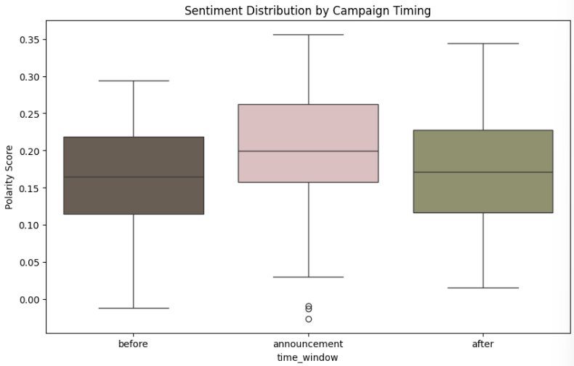

The boxplot shows that sentiment is highest during the announcement phase, indicating the most positive media coverage when the campaign launches. Before and after the announcement, sentiment is slightly lower and more stable, suggesting the campaign has a temporary lift in media tone. Increased variability during the announcement likely reflects differing opinions or concurrent news events.

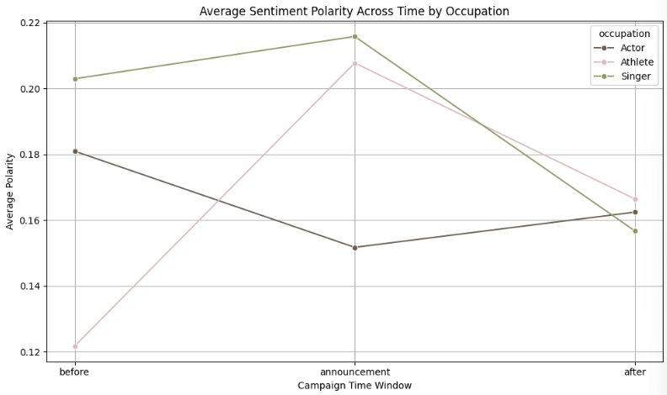

The line chart comparing sentiment by ambassador occupation reveals that athletes experience the greatest positive sentiment increase during the announcement, while singers maintain the highest sentiment levels overall. Actors, however, show relatively neutral sentiment over time. This suggests that the type of ambassador plays a significant role in how the media responds to the campaign.

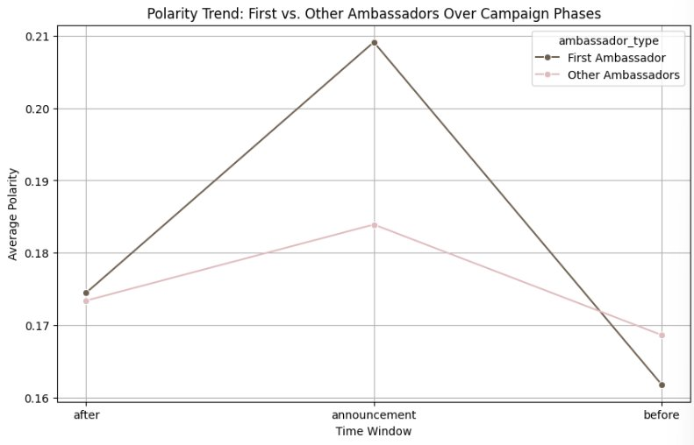

Lastly, comparing first-time vs. follow-up ambassadors, first-time campaigns trigger the sharpest sentiment spike, with the highest overall positivity. These campaigns often start with lower baseline sentiment, indicating that the novelty of a first-time ambassador creates a stronger media impact. Subsequent ambassadors show more stable sentiment trends.

In conclusion, first-time ambassadors and athlete ambassadors tend to generate more positive and dynamic media coverage.

Search Interest—lasya

**Strategic ambassador selection drives business impact.**

Whether a brand’s goal is to drive financial returns or to make a statement, strategic selection of an ambassador is necessary to maximize effects. Rising actors drive stronger financial effects, while athletes boost sentiment and search visibility. For brands introducing their first ambassador, novelty is likely to drive success on all metrics, but strategic selection is still crucial for setting the tone of future releases. All in all, choosing an ambassador presents strong opportunities for return; to adequately leverage a partnership, there should be a calculated effort in assessing the brand’s goals and compatibility between the brand’s image and the ambassador’s image.